BANASKANTHA DISTRICT KELVANI MANDAL SANCHALIT
Smt. B.K. Mehta I.T. Centre (BCA College)
Opp. S.T. Workshop, Highway, Palanpur – 385001


PROJECT REPORT
FreshMart
Online Fruits & Vegetables E-Commerce Platform

Submitted in partial fulfilment of Semester V
Subject 506 – Project Development | Academic Session 2026

PROJECT TEAM | ROLL NO. | EXAM NO
Purbiya Mit Nareshbhai | 66 | 666
Niye Dhruv Chmpklal | 22 | 633

Project Guide / Faculty: Hrdika Thakkar

CERTIFICATE
TO WHOM SO EVER IT MAY CONCERN
This is to certify that the project report titled “FreshMart: Online Fruits & Vegetables E-Commerce Platform” is submitted by the following students of Semester V, Subject 506 – Project Development, in partial fulfilment of the requirements of the Bachelor of Computer Applications programme at Smt. B.K. Mehta I.T. Centre (BCA College), Palanpur, affiliated to Hemchandracharya North Gujarat University, Patan, for the academic session 2026.
STUDENT NAME | ROLL NO. | EXAM NO
Purbiya Mit Nareshbhai | 66 | 666
Niye Dhruv Chmpklal | 22 | 633

Project Guide / Faculty: Hrdika Thakkar
Principal: Namrta S. Gupta
Date: ____________________ Place: Palanpur

INDEX
SR. NO. | DESCRIPTION | PAGE
1 | PROJECT PROFILE | 1
2 | CERTIFICATE | 2
3 | INDEX | 3
4 | PROJECT DETAILS | 4
5 | ABSTRACT | 5
6 | ACKNOWLEDGEMENT | 6
7 | 1. ABOUT THE INSTITUTE | 7
8 | 2. ABOUT THE SYSTEM | 8
9 | 3. CURRENT MANUAL SYSTEM AND NEED | 10
10 | 4. TECHNOLOGY USED | 11
11 | 5. SYSTEM REQUIREMENTS AND LOCAL SETUP | 12
12 | 6. DATABASE DESIGN | 14
13 | 7. DATA FLOW DIAGRAMS | 16
14 | 8. SCREEN LAYOUTS AND USER GUIDE | 17
15 | 9 SCREENSHORTS | 18
15 | 10. IMPLEMENTATION DETAILS AND SOURCE STRUCTURE | 27
16 | 11. APPLICATION MODULES | 29
17 | 12. CONCLUSION | 30
18 | 13. BIBLIOGRAPHY / REFERENCES | 31

PROJECT DETAILS
PROJECT ITEM | DETAIL
Project title | FreshMart: Online Fruits & Vegetables E-Commerce Platform
Project type | Web-based e-commerce application
Academic programme | Bachelor of Computer Applications, Semester V
Subject | 506 – Project Development
Academic session | 2026
Frontend | HTML5, CSS3, JavaScript, Bootstrap 5
Backend | PHP
Database | MySQL
Development tools | WAMP Server, Visual Studio Code
Project team | Purbiya Mit Nareshbhai (Roll No. 66); Niye Dhruv Chmpklal (Roll No. 22)

ABSTRACT
FreshMart is a web-based application for browsing and ordering fruits and vegetables online. It brings a product catalogue, search and category filters, product details, shopping cart, customer accounts and order placement into one interface. Customers can view product names, categories, prices, weights and images, and manage items in a browser-based cart before submitting an order.
The supplied project combines HTML5, CSS3, JavaScript and Bootstrap for responsive pages with PHP handlers and a MySQL database. PHP uses PDO to connect to the database. User registration stores password hashes, login verifies the hash and establishes a PHP session, and an authenticated customer can submit an order. Administrators can manage product records and view or update order status through PHP administration pages.
The source archive also contains static HTML screens for account, cart, checkout, profile, wishlist and administration experiences. Some depend on JavaScript and browser local storage. The submitted SQL export contains the users table; product and order definitions are supplied separately in PHP setup and migration scripts. The reviewed source does not show a payment gateway integration, so payment processing is documented as a proposed capability rather than a verified live feature.
FreshMart aims to make produce shopping convenient for customers and to provide a digital way to maintain catalogue, customer and order information. This report describes the project objectives, architecture, implementation evidence, database, setup requirements and main user workflows.

ACKNOWLEDGEMENT
We express our sincere gratitude to Banaskantha District Kelvani Mandal and Smt. B.K. Mehta I.T. Centre (BCA College), Palanpur, for providing the academic environment and resources needed to complete this project.
We are thankful to our faculty members, especially the faculty associated with Subject 506 – Project Development, for their guidance, suggestions and feedback throughout the planning, development and documentation of FreshMart.
We also thank our classmates and families for their encouragement and support. Developing this project gave us practical experience in building responsive web pages, connecting JavaScript interfaces with PHP handlers, working with MySQL, managing user sessions, and organizing product and order information.

1. ABOUT THE INSTITUTE
Banaskantha District Kelvani Mandal Sanchalit Smt. B.K. Mehta I.T. Centre (BCA College) is located opposite the S.T. Workshop on the Highway in Palanpur, Gujarat 385001. The sample project report identifies the college as affiliated to Hemchandracharya North Gujarat University, Patan.

Academic Context
FreshMart is prepared as a Semester V submission for Subject 506 – Project Development, in the Bachelor of Computer Applications programme, for the academic session 2026.

Project Team
STUDENT NAME | ROLL NO. | PROJECT
Purbiya Mit Nareshbhai | 66 | FreshMart
Niye Dhruv Chmpklal | 22 | FreshMart

2. ABOUT THE SYSTEM
FreshMart provides a browser-based storefront for fruits and vegetables. Visitors can browse the home and shop pages, search products, filter by category, sort results and open product details. The cart is managed in the browser with JavaScript local storage. Registered customers can create an account, sign in, place an order and review their orders. Administrators use protected PHP pages to maintain product records and process order statuses.

Problem Statement
In a conventional produce shop, customers may need to visit in person or contact the seller to learn which products are available, their prices and package weights. Orders and delivery progress may be tracked manually. A shared online catalogue and structured order record can make product discovery and order handling easier to follow.

Objectives
- Present fruit and vegetable products with names, categories, prices, weights and images.
- Support product search, category filtering and sorting in the shop catalogue.
- Provide account registration, login and session-based customer access.
- Allow customers to add items to a cart and submit an order.
- Store customer, product and order information in a MySQL database.
- Provide administrative pages for product management and order-status updates.
- Offer responsive page layouts for common desktop and mobile browsers.

Scope and User Roles
ROLE | MAIN ACTIVITIES
Visitor | Browse home page, shop catalogue, product details, about and contact pages.
Customer | Register, log in, maintain a profile, manage cart/wishlist in the browser, place orders and view own order records.
Administrator | Access protected dashboard, add/edit/delete products, inspect orders and update their status.
System | Serve HTML/CSS/JavaScript pages, process PHP requests and store database records.

Functional Modules
- Account management – registration, password hashing, login verification, session handling and logout.
- Product catalogue – bilingual English/Gujarati product labels, categories, prices, package weights and images.
- Shopping cart and wishlist – JavaScript and local storage support cart/wishlist state in the browser.
- Order handling – authenticated order submission, order number creation, order item records and customer order lookup.
- Administration – dashboard, product add/edit/delete operations and order listing/status changes.
- Profile – view account details and update a profile photo.

3. CURRENT MANUAL SYSTEM AND NEED

Typical Manual Process
- A customer visits a shop or contacts a vendor to ask which fruits and vegetables are available.
- The customer compares prices and quantities from displayed labels or direct discussion.
- Items are selected and the total is calculated at the counter or through messages.
- The order and delivery status may be tracked in a notebook or by follow-up calls.
- Customers repeat the enquiry because product and order information may not be available online.

Limitations and Web Approach
A web catalogue can present product details in one place and allow a customer to prepare an order from a cart. Persistent PHP/MySQL order records can help the customer and administrator retrieve transaction details. FreshMart source implements catalogue and order features, while delivery operations, payment collection and inventory synchronization depend on deployment procedures beyond what is demonstrated in the archive.

4. TECHNOLOGY USED
LAYER | TECHNOLOGY | ROLE IN FRESHMART
Markup | HTML5 | Page structure, forms, navigation, product cards and admin views.
Styling | CSS3 | Responsive layouts, typography, colours, spacing and custom storefront/admin styles.
Client behaviour | JavaScript | Search/filter/sort, product rendering, cart/wishlist local storage and order request submission.
UI framework | Bootstrap 5 | Responsive grid, navigation and common components; linked from a CDN.
Server language | PHP | Account handlers, session state, database operations, product administration and order processing.
Database interface | PDO | PHP connection and prepared statements for key account and order operations.
Database | MySQL | Stores accounts, products, orders and order items when setup scripts have run.
Development environment | WAMP Server, Visual Studio Code | Local Apache/PHP/MySQL environment and source-code editing.

Request and Data Path
A browser loads the HTML interface and JavaScript assets from the local PHP-capable web server. JavaScript renders catalogue content and keeps cart state in local storage. Account and order actions submit to PHP endpoints. PHP handlers read sessions, connect to MySQL with PDO, and return a page redirect or JSON response. Product image files are served from project image folders.

5. SYSTEM REQUIREMENTS AND LOCAL SETUP

Software Requirements
COMPONENT | REQUIREMENT
Operating system | Windows is suitable for the WAMP classroom setup.
Web server | Apache through WAMP or another PHP-capable web server.
PHP | PHP with PDO MySQL extension and file upload support enabled.
Database | MySQL-compatible server; SQL header reports MariaDB 10.4.32.
Browser | Current Chrome, Edge, Firefox or equivalent with JavaScript enabled.
Development tools | WAMP Server and Visual Studio Code.
External assets | Internet for Bootstrap, Bootstrap Icons and AOS CDN resources unless hosted locally.

Hardware Requirements
The source does not specify minimum processor, memory or storage values. A standard laptop or desktop that can run a local web server, PHP and MySQL is suitable for development and demonstration. A phone or desktop browser can be used to view responsive pages.

Local Setup Procedure
- Install WAMP Server and start Apache and MySQL services.
- Copy Fresh-Mart into the WAMP www document root.
- Create a MySQL database named freshmart and import freshmart.sql using phpMyAdmin.
- Run the table setup and migration scripts in the intended sequence to create product and order tables and required account columns. Review these scripts first because some alter or recreate tables.
- Check db_connect.php and set local database values for the WAMP installation. Do not publish real credentials.
- Open the project through the local server and confirm home, shop, registration, login, cart, checkout and admin flows.
- Ensure uploads is writable where profile images are used.
- Use a dedicated local test database and test accounts; do not use sample credentials on a public deployment.
The SQL export defines users only. Product and order tables are defined by migrate_db.php and setup_orders_table.php; role, profile_photo and mobile columns are added by separate migration scripts. A clean installation must apply the required schema scripts before using all application features.

6. DATABASE DESIGN
The project uses database freshmart. The SQL dump defines users. Additional source scripts define products, orders and order_items. This summary is based on the submitted SQL and PHP schema-creation scripts; it does not claim that all tables are present in the export file.

Entity Summary
ENTITY | PURPOSE | KEY RELATIONSHIP
users | Customer and administrator account information. | id is primary key; email is unique in dump. Orders reference users.id.
products | Catalogue with bilingual names/categories, price, weight and image. | id is the product key; order_items.product_id stores its identifier.
orders | Order header with order number, customer, amount, status and date. | user_id references users.id; one order has multiple order_items.
order_items | Order lines with item name, price, quantity and image. | order_id references orders.id and cascades on order deletion.

users
FIELD | TYPE / RULE | MEANING
id | INT, PK, AUTO_INCREMENT | Account identifier.
first_name | VARCHAR(50) | Customer first name.
last_name | VARCHAR(50) | Customer last name.
email | VARCHAR(100), UNIQUE | Login email.
password | VARCHAR(255) | Password hash.
role | ENUM user/admin; migration | Account role.
mobile, profile_photo | Optional migrated columns | Contact and profile image metadata.
created_at | TIMESTAMP | Account creation time.

products
FIELD | TYPE / RULE | MEANING
id | VARCHAR(50), PK | Product identifier.
en_name, gu_name | VARCHAR(255) | Product name in English and Gujarati.
en_category, gu_category | VARCHAR(100) | Category in English and Gujarati.
category_id | VARCHAR(50) | Category filter identifier.
price | DECIMAL(10,2) | Product price.
weight | VARCHAR(50) | Pack quantity/weight label.
img | VARCHAR(255) | Product image path.
created_at | TIMESTAMP | Product row creation time.

orders
FIELD | TYPE / RULE | MEANING
id | INT, PK, AUTO_INCREMENT | Internal order identifier.
order_number | VARCHAR(50), UNIQUE | Customer-facing order number.
user_id | INT, FK | Customer account.
total_amount | DECIMAL(10,2) | Order total.
status | VARCHAR(50), default Processing | Order state.
created_at | TIMESTAMP | Order creation time.

order_items
FIELD | TYPE / RULE | MEANING
id | INT, PK, AUTO_INCREMENT | Order line identifier.
order_id | INT, FK | Parent order.
product_id | VARCHAR(50) | Product identifier.
product_name | VARCHAR(255) | Name captured in the order.
price | DECIMAL(10,2) | Unit price captured for the order.
quantity | INT | Ordered quantity.
img | VARCHAR(255), nullable | Product image path.

Database Integrity Notes
orders.user_id references users.id with cascade deletion. order_items.order_id references orders.id with cascade deletion. migrate_db.php recreates products and seeds it from js/products.js. The SQL export and runtime schema scripts should be kept in sync before installation or deployment.

7. DATA FLOW DIAGRAMS
The diagrams below summarize the browser, PHP handlers and database interactions represented by the supplied source files.

Figure 7.1 System Context
ACTOR / COMPONENT | INTERACTION WITH FRESHMART
Customer | Browses catalogue; sends account, cart/order and profile requests; receives product and order responses.
Administrator | Signs in and submits product or order-status changes; receives admin views.
Web application | Serves storefront pages, processes PHP requests and generates catalogue/order responses.
MySQL database | Stores accounts, products, order headers and order lines.
Browser storage | Keeps cart and wishlist state in local storage.

Figure 7.2 Level 1 Data Flow
PROCESS | INPUT | OUTPUT / STORE
1. Browse catalogue | Search, category, sort selection | Filtered product cards.
2. Manage account | Registration/login form | users records and authenticated PHP session.
3. Manage cart | Add/remove/change quantity | Browser local storage.
4. Submit order | Signed-in user and cart items | orders and order_items records; order response.
5. Administer catalogue/orders | Admin session and form changes | Updated products or order status in MySQL.

Figure 7.3 Entity Relationships
users (1) ─── (many) orders ─── (many) order_items; products (1) ─── (many) order_items by product identifier. The schema stores item name and price snapshots on each order line.

Figure 7.4 Order Workflow
Select products → maintain cart in browser → sign in → submit order payload → PHP validates session and cart → create order and item lines in a transaction → return order number → administrator updates order status.

8. SCREEN LAYOUTS AND USER GUIDE
The FreshMart ZIP contains page source and product imagery rather than captured screenshots of a running application. The steps below describe the supplied pages and handlers.

Customer Workflow
- Open index.html through WAMP and select Shop.
- Search by product name, choose a category or sort the catalogue.
- Open a product detail page to review the selected product.
- Add products to cart and adjust or remove quantities on cart.html. Cart state is stored in browser local storage.
- Register through register.html or sign in through login.html.
- Proceed to checkout and submit the order. The PHP handler requires a logged-in session and records the order and item lines.
- Open orders.html to retrieve the signed-in customer’s order history through get_orders.php.

Administrator Workflow
- Sign in with an account assigned the admin role.
- Open the PHP administration dashboard.
- Use product management to add, edit or delete catalogue records.
- Open order management to review orders and change their status.
- Sign out when finished.

Main Page Inventory
SCREEN | SOURCE FILE | PURPOSE
Home | index.html | Brand landing page and navigation.
Shop | shop.html | Product cards with search, category filter and sorting.
Product details | product.html | Details for the product identified through a URL parameter.
Cart / checkout | cart.html; checkout.html | Review browser cart and begin order submission.
Registration / login | register.html; login.html | Customer account forms and access.
Orders / profile | orders.html; profile.html / profile.php | Order history and profile display or update.
Admin | admin_dashboard.php; admin_products.php; admin_orders.php | Dashboard, product maintenance and order-status operations.

9.Application Screenshots
The following screenshots were supplied for this report and show the FreshMart customer storefront and administration interface.

Customer Registration

Figure 8.1 Customer Registration
The registration screen collects first name, last name, email address, password and account type. A customer can use the sign-in link if an account already exists.

Customer Login

Figure 8.2 Customer Login
The login screen accepts an email address and password and provides links for password recovery and account registration.

FreshMart Home Page
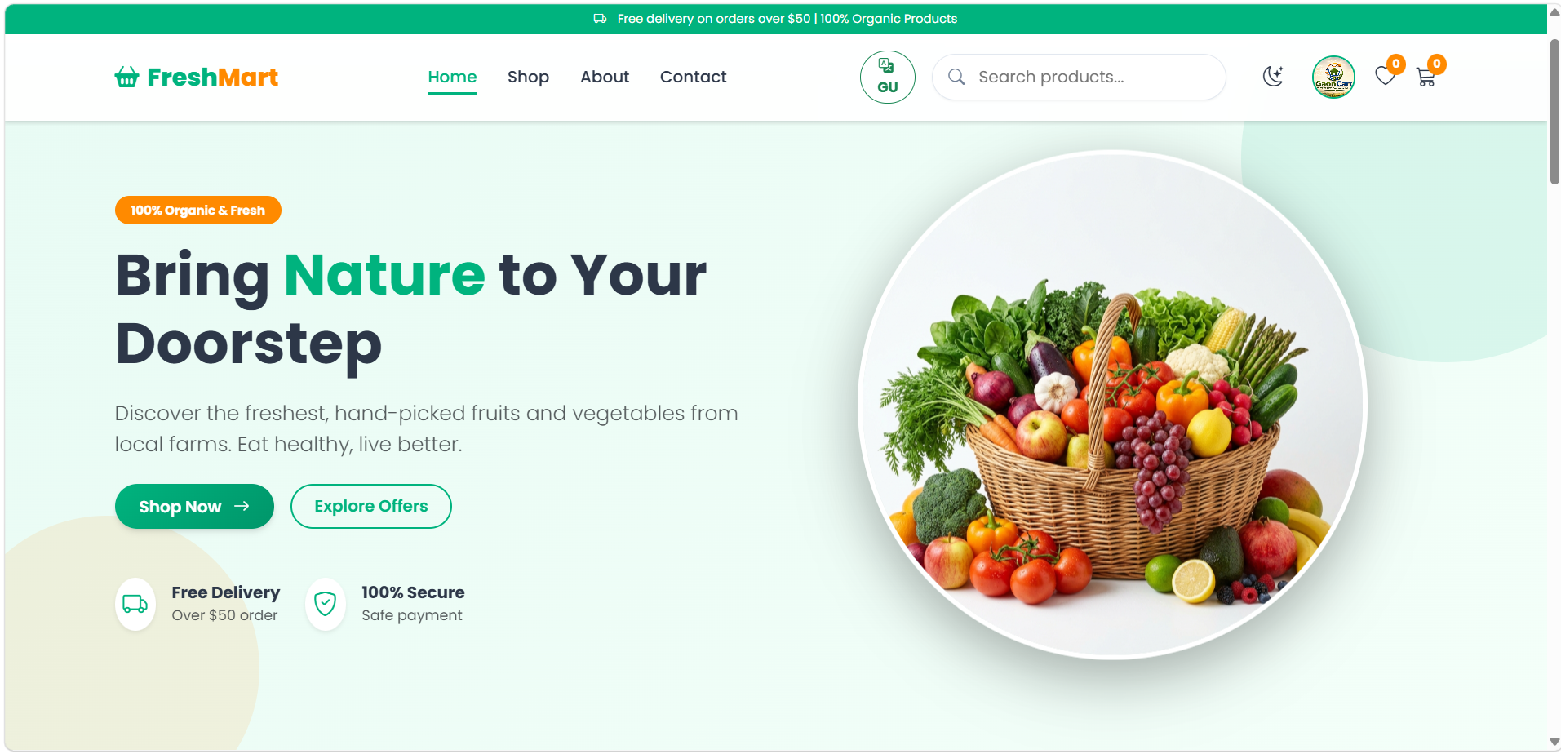
Figure 8.3 FreshMart Home Page
The home page presents FreshMart navigation, a search field, language control, cart and wishlist shortcuts, and a produce-focused hero area.

Shop Catalogue
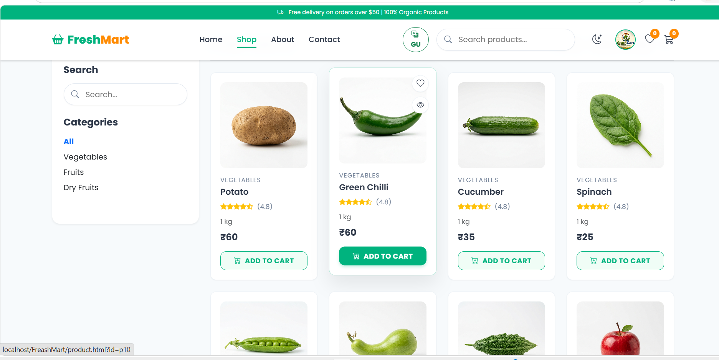
Figure 8.4 Shop Catalogue
The shop screen shows category filters and product cards with bilingual names, package weights, prices and add-to-cart actions.

Shopping Cart and Checkout
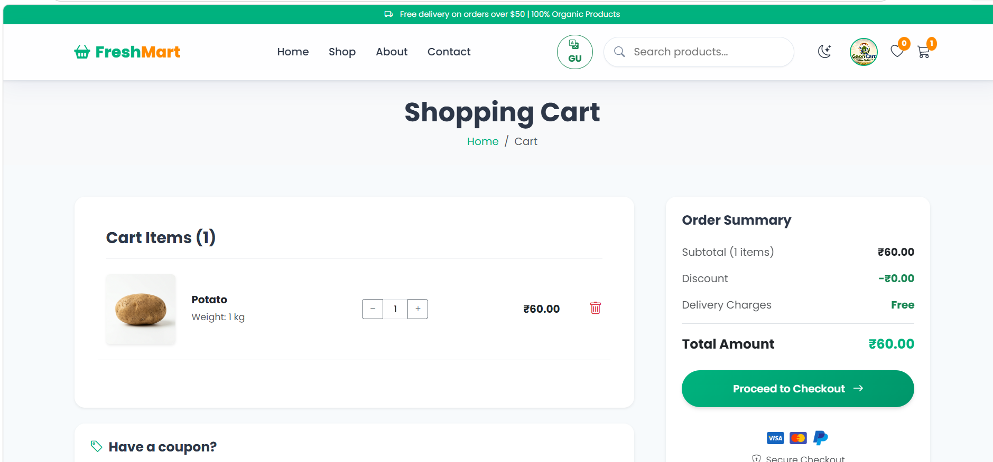
Figure 8.5 Shopping Cart and Checkout
The cart screen summarizes selected products, quantities, subtotal and total amount, and provides a control to proceed to checkout.

Administrator Dashboard
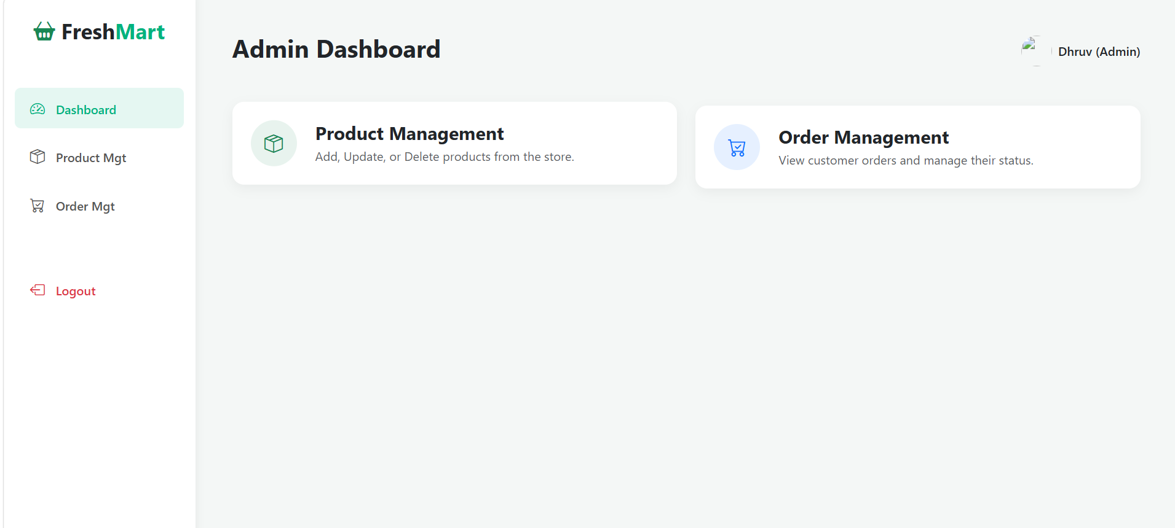
Figure 8.6 Administrator Dashboard
The administrator dashboard provides navigation to product management and order management.

Product Management
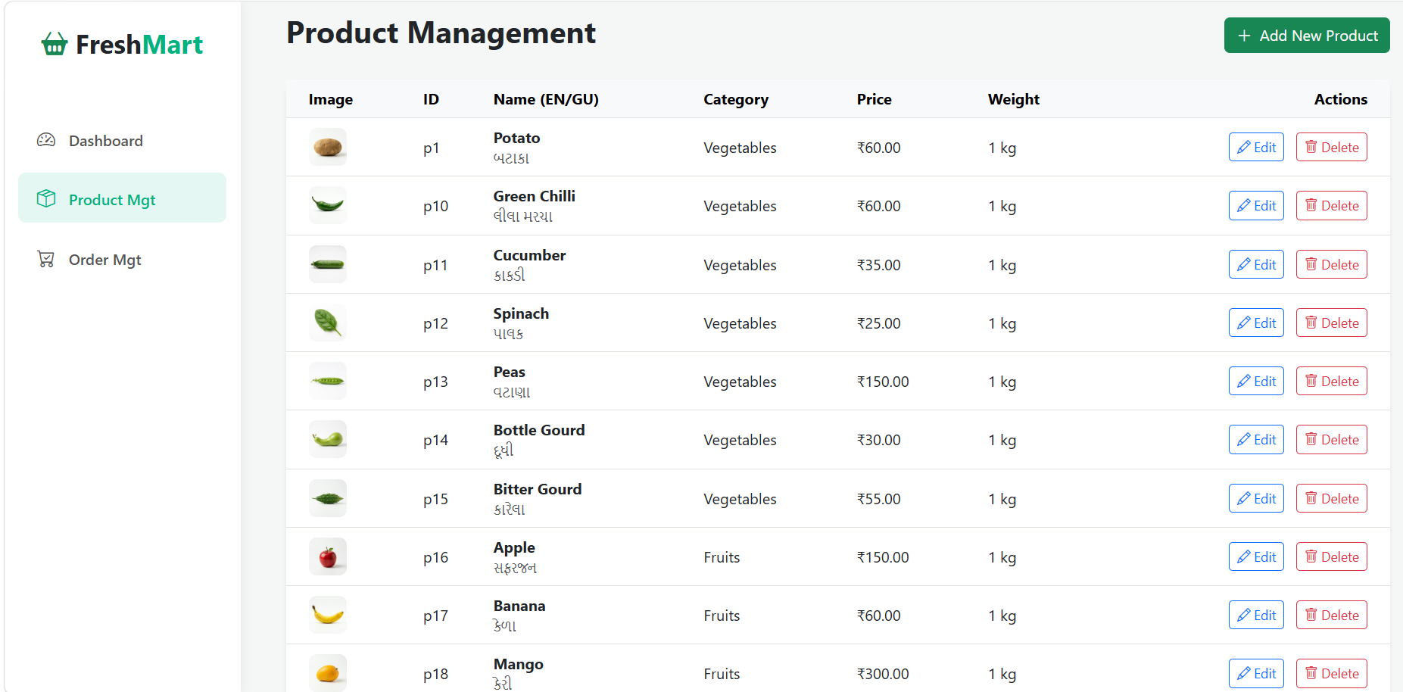
Figure 8.7 Product Management
The product management screen displays product images, identifiers, names, categories, prices and weights, with actions to add, edit or delete catalogue entries.

Order Management
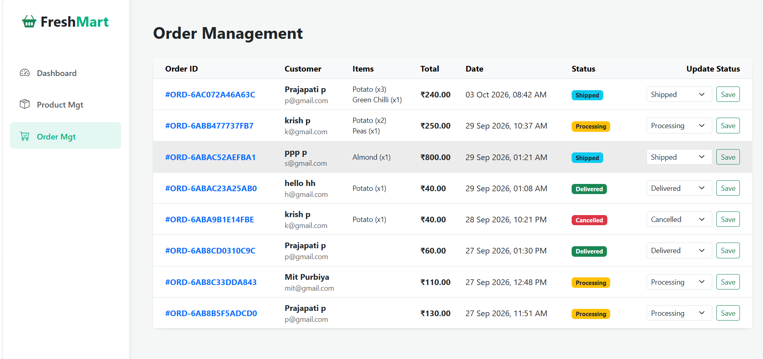
Figure 8.8 Order Management
The order management screen shows order identifiers, customer and item information, totals, dates and current status, with controls for updating status.

10. IMPLEMENTATION DETAILS AND SOURCE STRUCTURE
The archive contains HTML pages, PHP request handlers, JavaScript modules, CSS files, product images and database scripts. The storefront is partly static HTML with JavaScript-driven catalogue/cart behavior; PHP endpoints provide account, profile, order and administrator operations.
FILE / GROUP | IMPLEMENTATION ROLE
db_connect.php | PDO connection to local MySQL database freshmart.
index.html, shop.html, product.html | Storefront and product discovery pages.
js/products.js; get_products.php | Catalogue data and JSON retrieval; admin updates regenerate products.js.
js/main.js, shop_render.js, product-details.js | Cart/wishlist storage, filters and product detail rendering.
register_action.php, login_action.php, logout.php | Account registration, password verification, session and logout.
process_order.php, get_orders.php | Create customer orders/item lines and return signed-in user order history.
admin_dashboard.php, admin_products.php, admin_orders.php | Session-protected product/order administration.
profile.php, update_profile.php | Read profile and accept profile photo update.
freshmart.sql and setup/migration scripts | Base users schema and product/order/account schema setup.
css/, admin/css/, img/, uploads/ | Storefront/admin styles and product/profile media.

Processing Choices
- Passwords are created with PHP password_hash and verified with password_verify.
- Login regenerates the session identifier and stores customer identity and role in the session.
- Product search, category filters and sorting run in JavaScript on catalogue data.
- Cart and wishlist state are stored in browser local storage.
- Order creation checks the signed-in user, starts a transaction, inserts an order header and its item lines, and commits on success.
- Product management uses prepared statements and regenerates the JavaScript catalogue after a change.
- The source has static admin HTML prototypes and PHP-backed admin handlers; the PHP pages are the database-connected management routes described here.

Implementation Boundaries
The project definition mentions online payment options and delivery status. The archive shows order creation and editable order status, but no payment gateway or payment transaction code was found. Online payment is therefore treated as a future extension. Admin HTML includes customer and category/settings screens, while PHP administration chiefly demonstrates dashboard, products and orders. Stock decrement or reservation was not verified in the order handler.

11. APPLICATION MODULES

Account and Security Management
Registration checks required fields, checks whether an email is present and stores the password hash. Login verifies the password and starts a session with role information. PHP administration endpoints check the session role before product and order management.

Product Catalogue and Search
Product records contain English and Gujarati names and categories, a category identifier, price, weight label and image path. Shop JavaScript filters and sorts the catalogue and creates product cards. Product details are loaded from the selected product identifier.

Cart and Checkout
The cart is maintained in browser storage and can be edited before checkout. process_order.php accepts JSON containing cart items and total, requires a logged-in user, and writes an order plus its item rows inside a transaction. The handler returns an order number when successful.

Order History and Administration
get_orders.php retrieves orders for the signed-in account and formats their line items for the order page. admin_orders.php lists orders with account information and accepts status changes. The order schema initially labels a new order Processing; an administrator may update it.

Product Administration
admin_products.php checks the admin session, supports product insertion, editing and deletion through prepared statements, and regenerates JavaScript catalogue data after a change. Separate admin HTML pages demonstrate the intended dashboard interface, while PHP pages connect management functions to the database.

12. CONCLUSION
FreshMart brings produce discovery, browser-based cart management, customer accounts and database-backed order records into a single web application. Its HTML, CSS, JavaScript, Bootstrap, PHP and MySQL components provide a practical foundation for a local produce e-commerce workflow. Administration pages support product maintenance and order-status updates.
The project demonstrates an online fruit and vegetable catalogue and order workflow. To move from a classroom prototype to a complete commerce service, database setup scripts should be consolidated, catalogue and stock updates made consistent, payment integration added if required, and deployment security and delivery operations reviewed.

13. BIBLIOGRAPHY / REFERENCES
The following documentation and technologies are referenced by the project source:
- PHP Manual: https://www.php.net/docs.php
- MySQL Reference Manual: https://dev.mysql.com/doc/
- Bootstrap 5: https://getbootstrap.com/
- Bootstrap Icons: https://icons.getbootstrap.com/
- W3Schools HTML, CSS, JavaScript and PHP tutorials: https://www.w3schools.com/
- FreshMart source archive: FreshMart.zip, supplied for this report.

